Navigating the Data Architecture Crossroads: ABC Consulting’s Poultry Innovation Initiative

Name: Mohamed Ashraaf Ibrahim
Student ID: S2402243
UWE ID: 25024336
Course: MSc In Information Technology - May 2025
Module: Big Data
College: Villa College
Lecturer: Margret Vijay
Date: 27/12/2025
Word Count: 2479

Abstract
This report provides a focused evaluation of database architecture options for ABC Consulting’s strategic initiative to integrate big data and predictive analytics into its commercial poultry production operations. The poultry farming sector is increasingly leveraging data from IoT sensors and operational systems to enhance efficiency, sustainability, and animal welfare. The critical decision between traditional SQL (Relational) and modern NoSQL (Non-relational) databases will fundamentally shape the company’s ability to achieve its objectives of real-time environmental monitoring, reduction of feed waste, and generation of predictive health insights. This paper evaluates these architectural choices against key operational and technical criteria. By conducting a balanced, scenario-specific evaluation, this report provides a strategic framework to guide ABC Consulting in selecting a scalable, robust, and future-proof data infrastructure fit for a leader in data-enabled agriculture.

Table of Contents
Abstract 2
List of Tables 4
List of Figures 5
List of Abbreviations 6
Introduction 7
1. Dataset Types and Data Characteristics 9
2. Data Processing and Storage Requirements 11
3. Organisation Readiness and Affordability 13
4. Data Quality Requirements 15
5. Knowledge Retrieval, Analytics, and Decision Support 17
6. Data Privacy and Security Issues 19
7. Synthesis and Recommendations 20
Conclusion 23
References 24

List of Tables
Table 1: Poultry Production Data Matrix and Database Suitability 10
Table 2: Data Processing Requirements Comparison 11
Table 3: Scalability Comparison - Vertical vs. Horizontal 12
Table 4: Organisational Readiness Factors 13
Table 5: Consequences of Low-Quality Data in Poultry Operations 16
Table 6: Poultry Production Domain Ontology with Entity Relationships 17
Table 7: Database Security Features Comparison 19
Table 8: Recommended Architecture Components 21
Table 9: Summary Decision Matrix for Database Architecture 21

List of Figures
Figure 1: Conceptual Framework for Database Architecture Decision 8
Figure 2: Data Quality and Processing Pipeline 16
Figure 3: Poultry Production Decision Support Dashboard (Wireframe) 18
Figure 4: Recommended Hybrid Data Architecture for ABC Consulting 20

List of Abbreviations

AI | Artificial Intelligence
ACID | Atomicity, Consistency, Isolation, Durability
BASE | Basically Available, Soft state, Eventually consistent
BI | Business Intelligence
CAP | Consistency, Availability, Partition tolerance
DSS | Decision Support System
ERP | Enterprise Resource Planning
ETL | Extract, Transform, Load
GDPR | General Data Protection Regulation
HPAI | Highly Pathogenic Avian Influenza
IoT | Internet of Things
KPI | Key Performance Indicator
LDAP | Lightweight Directory Access Protocol
MFA | Multi-Factor Authentication
ML | Machine Learning
NoSQL | Not Only SQL
RDBMS | Relational Database Management System
SQL | Structured Query Language
TCO | Total Cost of Ownership
TDE | Transparent Data Encryption

Introduction
The agricultural sector is undergoing a profound digital transformation, with data emerging as a critical asset for optimising operations and ensuring sustainability. For the poultry industry, this evolution presents a significant opportunity to move beyond traditional farming practices towards precision agriculture. ABC Consulting’s ambition to lead this change by applying data-enabled innovations to commercial broiler production is both timely and strategic. The objectives—to develop infrastructure for real-time data capture, generate predictive insights, reduce feed waste, and improve chicken survivability—are central to building a competitive and resilient business (Franzo et al., 2023).
Central to this data-driven enterprise is the choice of a foundational data processing infrastructure. The choice between a traditional SQL database, a modern NoSQL database, or a hybrid model is a foundational decision impacting long-term scalability, flexibility, and analytical capability. This is not merely a technical choice but a strategic one that will determine the company’s ability to harness its data assets. Given this is ABC Consulting’s first venture into big data, a careful evaluation is essential to mitigate risks and ensure the selected architecture is fit for purpose.
To address this challenge, this report provides a balanced evaluation of these database architectures against the unique requirements of the poultry production industry. The analysis is structured around the six core evaluation criteria conceptualised in Figure 1, providing a comprehensive framework for this critical decision.
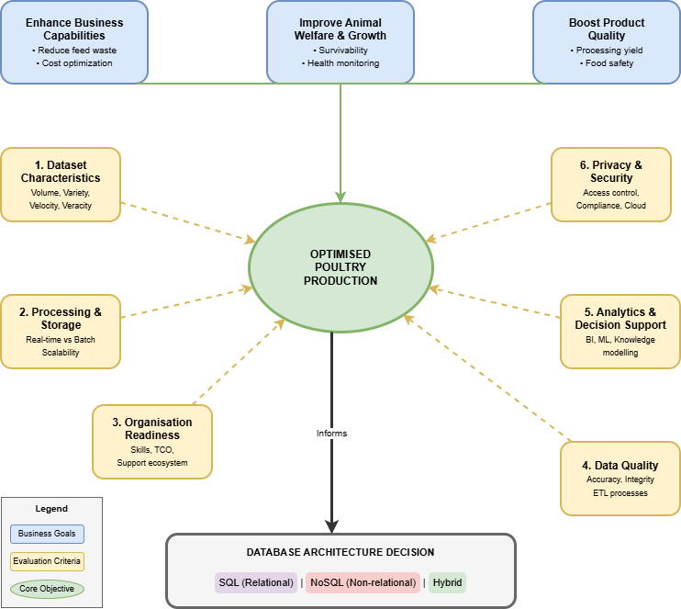
Figure 1: Conceptual Framework for Database Architecture Decision

1. Dataset Types and Data Characteristics
A modern poultry farm is a prolific generator of diverse data, showcasing the primary characteristics of big data: volume, velocity, variety and veracity (Leishman et al., 2023). The veracity dimension is critical in this context, as sensor data from harsh farm environments may be prone to inaccuracies that must be addressed through data quality processes. Understanding these characteristics is the first step in designing an effective data architecture.
ABC Consulting’s data landscape will include highly structured data, such as financial records from an ERP system, feed inventory, mortality counts, processing yields, and employee data. These datasets are characterised by stable formats and are critical for core business operations and reporting. SQL databases, with their relational model and strict schema enforcement adhering to ACID (Atomicity, Consistency, Isolation, Durability) properties, are exceptionally well-suited for this data, ensuring transactional integrity (Marmelstein et al., 2024). In contrast, many NoSQL databases operate on a principle of BASE (Basically Available, Soft state, Eventually consistent), prioritising availability over strict consistency, which is better suited for high-volume, less structured data streams.
Conversely, the primary driver of ABC’s big data initiative will be the high-velocity, heterogeneous data from Internet of Things (IoT) sensors and monitoring systems. This includes semi-structured environmental data (temperature, humidity, ammonia levels), often generated in formats like JSON every few seconds (Bumanis et al., 2022). Furthermore, unstructured data such as audio files for monitoring flock vocalisations (an indicator of stress or disease) and high-volume video feeds for tracking bird behaviour are becoming vital for animal welfare and productivity analysis (Poudel et al., 2025). A traditional SQL database would struggle to manage this heterogeneity efficiently, requiring the forcing of flexible sensor data into rigid tabular structures or storing large files as binary objects, which makes querying difficult. In contrast, NoSQL databases are designed for this variety—document databases can store JSON-like sensor logs natively, while object stores are ideal for large unstructured files.
Data Source | Data Type | Structure | Velocity | SQL Suitability | NoSQL Suitability | Primary Use Case
Financial System | Sales, Expenses | Structured | Low | High | Low | Financial Reporting
Environmental Sensors | Temp, Humidity, NH₃ | Semi-Structured | High (Real-time) | Low | High | Real-time Alerts, Anomaly Detection
Feed Management | Consumption, Inventory | Structured | Medium | High | Medium | Inventory Optimisation
Video/Audio Monitoring | CCTV, Acoustic Recordings | Unstructured | High (Streaming) | Low | High | Behaviour Analysis, Disease Prediction
Processing Plant | Yield, Quality Grades | Structured | Medium | High | Low | Supply Chain Management
Health Records | Veterinary Logs, Medication | Semi-Structured | Low-Medium | High | Medium | Health & Compliance Tracking
Table 1: Poultry Production Data Matrix and Database Suitability
Key: High = Optimal fit; Medium = Workable; Low = Poor fit with significant limitations.

2. Data Processing and Storage Requirements
ABC Consulting’s objectives require both real-time responsiveness for immediate operational decisions and deep historical analysis for strategic planning. These dual needs place distinct demands on the data infrastructure. Real-time sensor ingestion is crucial for generating immediate alerts for issues like a sudden temperature drop or a rise in ammonia levels, which can prevent mass mortality events. This requires a database capable of handling high-speed data writes, a strength of many NoSQL systems.
This trade-off between consistency and availability is formalised in the context of the CAP theorem, which posits that a distributed system can only guarantee two of three properties—Consistency, Availability, and Partition tolerance—traditional SQL databases typically prioritise Consistency, ensuring all users see the same data, and may sacrifice Availability during a network partition (Kumar, 2023). Conversely, many NoSQL databases are architected to prioritise Availability over immediate Consistency, accepting ‘eventual consistency’ to ensure the system remains operational for data ingestion even if some nodes are temporarily out of sync. For ABC Consulting, this means choosing between immediate data accuracy (SQL) for critical financial transactions versus high availability (NoSQL) for continuous sensor data ingestion where brief inconsistencies are acceptable.
Processing Requirement | SQL Capability | NoSQL Capability | Recommended For
Real-time Sensor Ingestion | Low - Write bottlenecks at scale | High - Horizontal scaling | NoSQL
Transactional Processing | High - ACID compliance | Low - Eventual consistency | SQL
Batch Historical Analysis | High - Complex JOINs | Medium - Requires additional frameworks | SQL
Predictive Model Training | Medium - Scale limitations | High - Distributed processing | NoSQL
Ad-hoc Business Queries | High - SQL is the standard | Low - Less mature query languages | SQL
Large File (Video/Audio) Storage | Low - BLOB storage inefficient | High - Object stores designed for this | NoSQL
Table 2: Data Processing Requirements Comparison
Beyond immediate processing needs, the long-term viability of the chosen architecture depends on its ability to scale. As ABC Consulting deploys more sensors and retains data from more production cycles, data volume will grow exponentially. This makes the underlying architecture’s scalability a key consideration for future-proofing the investment
For a growing business like ABC Consulting, the exponential cost curve of vertically scaling a single powerful SQL server could become a significant financial burden. In contrast, the linear cost model of horizontally scaling a NoSQL cluster by adding more commodity servers offers a more predictable and potentially lower Total Cost of Ownership (TCO) at scale.
Scaling Approach | SQL (Traditional RDBMS) | NoSQL (Distributed)
Method | Vertical (Scale-up) | Horizontal (Scale-out)
Hardware | More powerful, expensive servers | Commodity hardware clusters
Cost Curve | Exponential at large scale | Linear with data growth
Table 3: Scalability Comparison - Vertical vs. Horizontal

3. Organisation Readiness and Affordability
As a first-time adopter of a large-scale data platform, ABC Consulting must realistically assess its internal capabilities and the TCO. Beyond technical skills, organisational readiness involves fostering a data-centric culture. Stakeholders, from farm managers to veterinarians, may be reluctant to share data or adopt new digital tools due to concerns about complexity or a lack of perceived benefit (Chapot et al., 2024). A successful implementation will require not just hiring technical staff but also investing in training and change management to demonstrate the value of these new data-driven insights.
The mature talent pool for SQL makes recruitment straightforward. In contrast, expertise in specific NoSQL technologies can be scarcer and more expensive. While many NoSQL databases are open-source, their operational complexity can be higher than traditional SQL systems. This translates to higher costs for specialized staff or for cloud-based managed services.
Factor | SQL Databases | NoSQL Databases | Impact for ABC Consulting
Talent Availability | High - Mature market | Medium - Specialist skills less common | SQL expertise is easier to recruit and retain.
Training Effort | Low - Widely taught in IT curricula | Medium-High - Technology-specific training needed | Lower initial training investment required for SQL.
Community & Documentation | Extensive - Decades of resources | Growing - Varies by technology | SQL offers more established troubleshooting resources.
Vendor Support | Strong - Commercial & open-source options | Variable - Some technologies lack enterprise support | Support SLAs are critical for mission-critical systems.
Table 4: Organisational Readiness Factors

ABC must weigh the lower initial cost of leveraging existing SQL expertise against the long-term scalability and flexibility benefits of a managed NoSQL service. Data analytics can drive significant cost optimisation in inventory management and logistics, reducing waste and improving supply chain efficiency, which helps build a clear business case for this investment (Kler et al., 2022).

4. Data Quality Requirements
The accuracy of ABC Consulting’s predictive models and operational alerts will depend entirely on the quality of the underlying data. Inaccurate data can lead to flawed business decisions, such as incorrect feed formulations or a failure to detect disease outbreaks, with severe financial consequences (Alders and Tomley, 2022). For instance, in bio-mapping studies tracking Salmonella in poultry processing, inconsistent data collection can render food safety decisions unreliable (Vargas et al., 2023).
SQL databases enforce data quality at the point of entry through a rigid schema and strict integrity constraints (ACID compliance). This is essential for transactional systems. However, this rigidity can lead to data loss if incoming sensor data deviates from the predefined format. In contrast, NoSQL databases often employ a flexible ‘schema-on-read’ approach, ingesting data in its native format without immediate validation. While this provides resilience against variations in sensor data, it crucially shifts the burden of data cleansing, validation, and quality enforcement to the analytics pipeline downstream (Bumanis, 2024).
A robust data quality strategy is essential regardless of the database choice. This involves implementing Extract, Transform, and Load (ETL) processes that clean, validate, and standardize data before it is used for critical analytics. For ABC, this means extracting data from sensors, transforming it into a consistent format (e.g., standardizing temperature to Celsius), and loading it into the appropriate database. Such processes are crucial, as even sample preparation methods can significantly impact analytical results (Gogé et al., 2021).
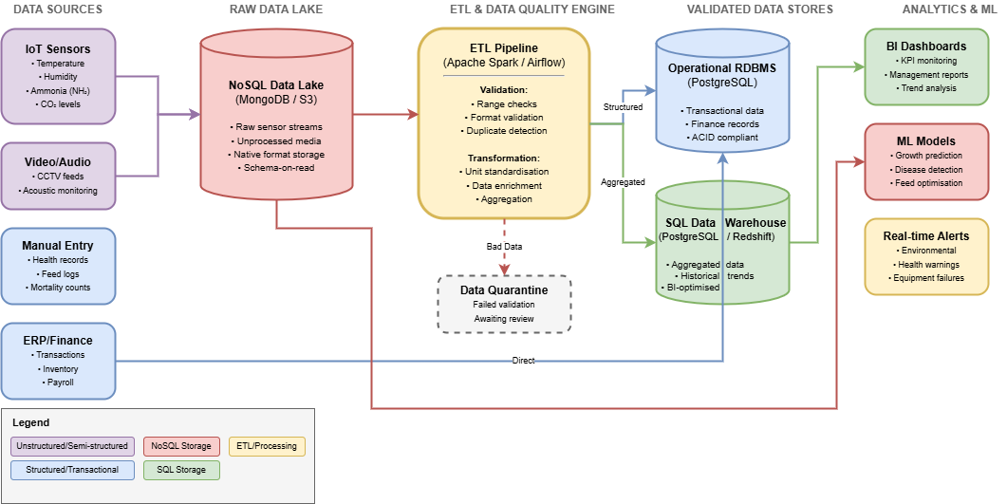
Figure 2: Data Quality and Processing Pipeline
As illustrated in Figure 2, data from IoT sensors, video/audio systems, and ERP platforms flows into an ETL and Data Quality Engine. Validated data proceeds to Analytical Stores (Data Warehouse/Lake), while records that fail validation are sent to a Data Quarantine for review.
Data Quality Issue | Operational Impact | Financial Impact | Strategic Impact
Inaccurate Sensor Readings | False alarms or missed events (e.g., ventilation failure) | Increased flock mortality, wasted energy | Loss of trust in data-driven decision-making
Incomplete Health Records | Unreliable disease detection models | Increased veterinary costs, reduced yield | Regulatory compliance risks, brand damage
Delayed Environmental Data | Slow response to critical issues like heat stress | High mortality rates from heat stress | Reputational damage among customers
Inconsistent Feed Data | Incorrect feed formulation and distribution | Increased feed costs, poor growth rates | Inability to optimise for feed conversion ratio
Table 5: Consequences of Low-Quality Data in Poultry Operations

5. Knowledge Retrieval, Analytics, and Decision Support
The ultimate goal of ABC’s data infrastructure is to generate actionable knowledge to support better decision-making. SQL is the native language of data analysis, making it ideal for business intelligence (BI) dashboards reporting on key performance indicators (KPIs) like feed conversion ratios and production costs. For the retrospective analysis ABC requires, a SQL-based data warehouse is highly effective.
Beyond traditional querying, ABC Consulting should consider knowledge modelling to enhance information retrieval. An ontology would formally define the entities, such as ‘broiler flock’, ‘feed batch’, ‘ventilation system’, and the relationships between them. For example, it could be codified that ‘elevated ammonia reading’ indicates ‘ventilation failure’, which causes ‘respiratory stress’. This structured knowledge allows for more intelligent, context-aware queries and root-cause analysis. Graph databases, a category of NoSQL, are well-suited for storing and querying such interconnected knowledge structures, enabling ABC to move from raw data to actionable domain knowledge.
Entity (Class) | Relationship | Related Entity | Information Retrieval Query
Flock | is housed in | Barn | Retrieve all flocks in Barn A with mortality > 2%
Flock | consumes | Feed Batch | Which feed batches were consumed by flocks with poor growth rates?
Flock | has recorded | Health Event | List all flocks that experienced respiratory illness in Q3
Barn | contains | Environmental Sensor | Show all sensors in barns exceeding ammonia thresholds
Environmental Sensor | monitors | Environmental Condition | Which sensors detected temperature anomalies last week?
Environmental Sensor | generates | Sensor Reading | Retrieve hourly humidity readings for Barn B
Sensor Reading | indicates | Alert Condition | Find all readings that triggered heat stress alerts
Table 6: Poultry Production Domain Ontology with Entity Relationships

Figure 3 presents a wireframe for a potential dashboard for ABC’s farm managers, integrating data from multiple sources to provide a holistic view. The KPIs on production costs would be powered by queries on a SQL data warehouse, while the ‘Real-time Environmental Status’ and ‘Predictive Alerts’ would be fed by a fast, scalable NoSQL database processing live sensor data.
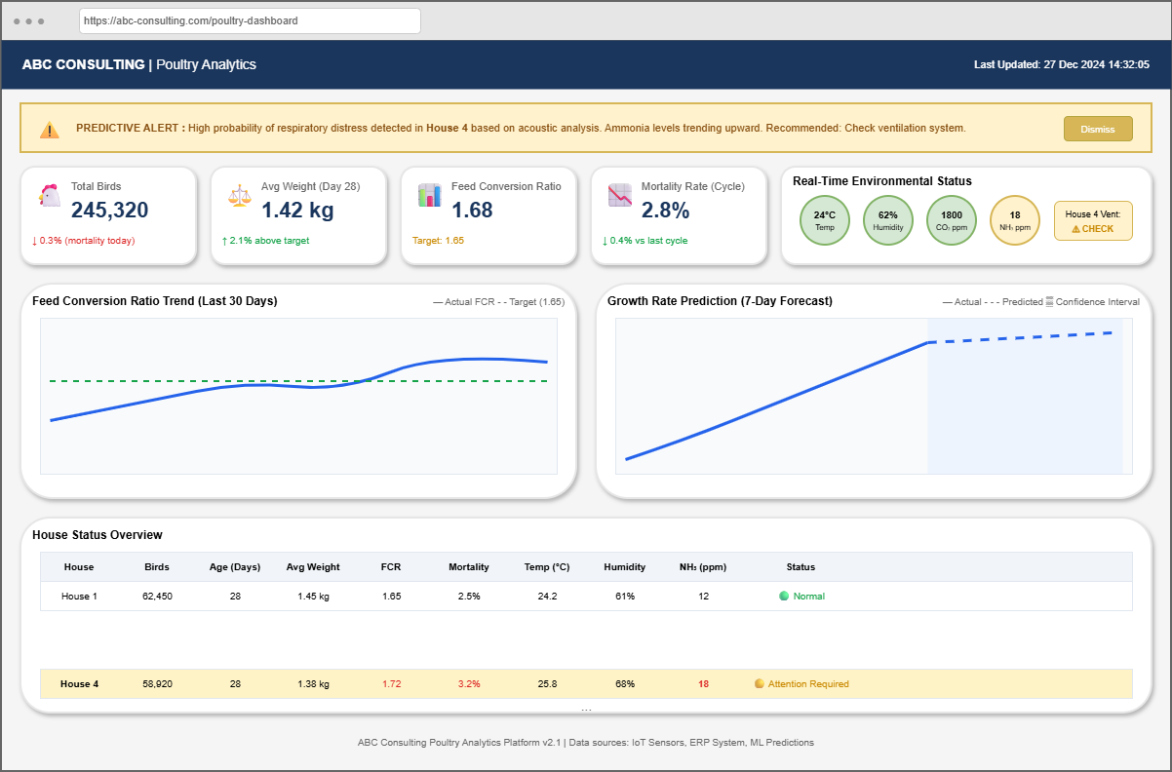
Figure 3: Poultry Production Decision Support Dashboard (Wireframe)
Machine Learning (ML) models, such as those predicting disease outbreaks based on live data patterns (Yoon et al., 2022), often need to process enormous volumes of diverse data. NoSQL databases are frequently selected as the backend for ML applications due to their ability to handle diverse data types at scale (Leishman et al., 2023).

6. Data Privacy and Security Issues
As ABC Consulting aggregates vast amounts of proprietary and sensitive data, ensuring its privacy, security, and integrity is paramount. The security of this data is critical; a breach could lead to operational disruption and a loss of competitive advantage. For instance, proprietary data on feed formulations is a valuable target for corporate espionage.
SQL databases generally feature mature, robust security models with granular access controls down to the row and column level. The landscape for NoSQL is more varied, though leading databases now offer strong enterprise-grade features. Choosing a cloud deployment offers scalability but requires understanding the shared responsibility model, where ABC is responsible for security in the cloud (Chapot et al., 2024). Building trust with stakeholders hesitant about third-party data storage is critical. Therefore, a strong data governance framework is non-negotiable, ensuring compliance with regulations like GDPR and protecting sensitive data used for HPAI risk assessment (Yoon et al., 2022).
Security Feature | SQL Databases | NoSQL Databases
Authentication | Strong - MFA, LDAP integration | Strong - Improving; enterprise auth
Authorisation | Granular - Row/column level | Variable - Document/collection level
Encryption at Rest | Standard - Native TDE support | Standard - Available in enterprise versions
Audit Logging | Comprehensive - Built-in trails | Variable - Varies by technology
Compliance Certifications | Extensive - SOC 2, ISO 27001 | Growing - Major vendors certified
Table 7: Database Security Features Comparison

7. Synthesis and Recommendations
After a balanced evaluation of SQL and NoSQL databases against ABC Consulting’s specific requirements, it is clear that a one-size-fits-all approach is suboptimal. A purely SQL architecture would fail to scale cost-effectively for live sensor data, while a purely NoSQL architecture would lack the transactional integrity and mature query ecosystem required for core business systems. Therefore, the most robust, scalable, and future-proof solution is a Hybrid Model that leverages the distinct strengths of both paradigms.
Figure 4 illustrates this proposed hybrid architecture. Data from IoT sensors and other high-volume sources is ingested into a flexible NoSQL data lake. Simultaneously, transactional data from ERP systems is managed by a reliable operational SQL database. An ETL pipeline then processes and transfers relevant data from both sources into a structured SQL data warehouse, optimized for BI, while the data lake directly feeds ML models.
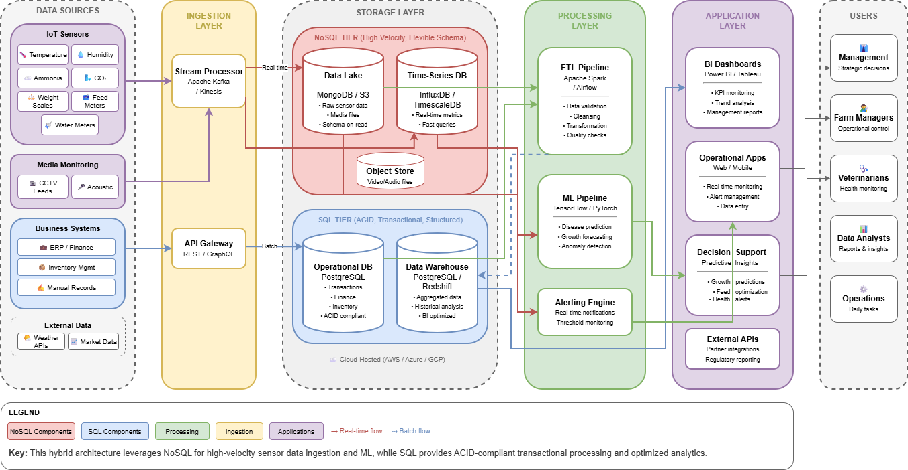
Figure 4: Recommended Hybrid Data Architecture for ABC Consulting

Component | Purpose | Recommended Technology | Database Type
Data Lake | High-volume raw sensor data ingestion | MongoDB Atlas / Amazon S3 | NoSQL
Operational Database | Core business transactions (ERP, Finance) | PostgreSQL / SQL Server | SQL
Data Warehouse | BI and historical analysis | PostgreSQL / Snowflake | SQL
Time-Series Store | Real-time sensor monitoring & dashboards | InfluxDB / TimescaleDB | NoSQL
ML Feature Store | Training data for predictive models | MongoDB / Delta Lake | NoSQL
Table 8: Recommended Architecture Components
This hybrid approach allows ABC Consulting to use the right tool for the right job, ensuring performance, scalability, and integrity across all business functions.
Evaluation Criterion | SQL Recommendation | NoSQL Recommendation | Hybrid Advantage
Dataset Characteristics | Structured transactional | Semi/unstructured sensor | Handles the full variety of data without compromise.
Processing Requirements | Complex analytical queries | Real-time high-velocity ingestion | Meets both real-time and batch processing needs.
Organisation Readiness | Leverages existing skills | Cloud-managed reduces complexity | Allows for gradual capability building and phased adoption.
Data Quality | Enforces integrity at entry | Flexible ingestion + downstream validation | A dedicated quality pipeline bridges both worlds.
Analytics/Decision Support | BI and ad-hoc reporting | ML and real-time alerting | Enables the full spectrum of analytics.
Security | Mature, granular controls | Improving, distributed complexity | A defense-in-depth strategy can be implemented.
Table 9: Summary Decision Matrix for Database Architecture

Implementation Recommendation: A phased approach is advised.
Phase 1: Foundational Data Capture.
This initial phase should focus on establishing the core infrastructure: the NoSQL data lake for high-velocity sensor data ingestion and the operational RDBMS for core business transactions. This allows the organisation to build expertise with both technologies on manageable, distinct use cases while immediately starting to capture valuable raw data.
Phase 2: Advanced Analytics and Insight Generation.
Building on the foundation of Phase 1, this stage focuses on value extraction. Key activities include constructing the SQL data warehouse to enable business intelligence and historical analysis, and leveraging the data lake to develop the first predictive Machine Learning (ML) models. This ensures that the investment in advanced analytics is made only once sufficient data has been collected and the technical team’s expertise has matured.

Conclusion
The decision to invest in a modern data infrastructure is a pivotal moment for ABC Consulting. This analysis has moved beyond a simple binary choice between SQL and NoSQL, advocating instead for a nuanced, hybrid architecture tailored to the complex demands of modern poultry production.
By adopting the recommended model, which strategically combines the transactional integrity of SQL with the scalable flexibility of NoSQL, ABC Consulting can build a resilient and powerful data platform. This is more than a technical upgrade; it is a strategic enabler. The proposed architecture will directly empower the company to achieve its core business objectives: enhancing animal welfare and survivability through live monitoring, eliminating inefficiencies through precise data analysis, and ultimately, delivering a higher quality product. This investment will be the foundational pillar in ABC Consulting’s journey to becoming a leader in efficient, sustainable, and data-informed agriculture, securing a decisive competitive advantage in a rapidly evolving industry.

References
Alders, R. and Tomley, F. (2022) Animal Board Invited Opinion Paper: Planet, people and poultry - more and better data needed to get the balance right, Animal [online]. 16(7), p. 100560. [Accessed 22 December 2025].
Bumanis, N. (2024) Overcoming Data Limitations in Precision Poultry Farming: Processing and Data Fusion Challenges, Procedia Computer Science [online]. 232, pp. 2302–2309. [Accessed 20 December 2025].
Bumanis, N., Arhipova, I., Paura, L., Vitols, G. and Jankovska, L. (2022) Data Conceptual Model for Smart Poultry Farm Management System, Procedia Computer Science [online]. 200, pp. 517–526. [Accessed 19 December 2025].
Chapot, L., Hibbard, R., Ariyanto, K.B., Maulana, K.Y., Yusuf, H., Febriyani, W., Cameron, A., Paul, M., Vergne, T. and Faverjon, C. (2024) Needs and capabilities for improving poultry production and health management in Indonesia, PLOS ONE [online]. 19(8), p. e0308379. [Accessed 21 December 2025].
Franzo, G., Legnardi, M., Faustini, G., Tucciarone, C.M. and Cecchinato, M. (2023) When Everything Becomes Bigger: Big Data for Big Poultry Production, Animals [online]. 13(11), p. 1804. [Accessed 22 December 2025].
Gogé, F., Thuriès, L., Fouad, Y., Damay, N., Davrieux, F., Moussard, G., Le Roux, C., Trupin-Maudemain, S., Valé, M. and Morvan, T. (2021) Performance of near infrared spectroscopy of a solid cattle and poultry manure database depends on the sample preparation and regression method used, Journal of Near Infrared Spectroscopy [online]. 29(4), pp. 226–235. [Accessed 24 December 2025].
Kler, R., Gangurde, R., Elmirzaev, S., Hossain, M.S., Vo, N.V.T., Nguyen, T.V.T. and Kumar, P.N. (2022) Optimization of Meat and Poultry Farm Inventory Stock Using Data Analytics for Green Supply Chain Network, Discrete Dynamics in Nature and Society [online]. 2022, pp. 1–8. [Accessed 23 December 2025].
Kumar, S. (2023) Dataversity. No Database Is Perfect: Applying CAP Theorem to Database Choice [online]. Available from: https://www.dataversity.net/no-database-is-perfect-applying-cap-theorem-to-database-choice/ [Accessed 27 December 2025].
Leishman, E.M., You, J., Ferreira, N.T., Adams, S.M., Tulpan, D., Zuidhof, M.J., Gous, R.M., Jacobs, M. and Ellis, J.L. (2023) Review: When worlds collide – poultry modeling in the ‘Big Data’ era, Animal [online]. 17(7), p. 100874. [Accessed 20 December 2025].

Marmelstein, S., de Araújo Costa, I.P., Terra, A.V., da Silva, R.F., de Oliveira Capela, G.P., Moreira, M.Â.L., de Souza Rocha Junior, C., Simões Gomes, C.F. and dos Santos, M. (2024) Advancing Efficiency Sustainability in Poultry Farms through Data Envelopment Analysis in a Brazilian Production System, Animals [online]. 14(5), p. 726. [Accessed 21 December 2025].
Poudel, A., Davis, J.D., Purswell, J.L., Sharma, S. and Brown-Brandl, T.M. (2025) Semi-automatic annotation system based on Segment Anything Model for large scale poultry data annotations, Animal - Science Proceedings [online]. 16, pp. 672–674. [Accessed 23 December 2025].
Vargas, D.A., De Villena, J.F., Larios, V., Bueno López, R., Chávez-Velado, D.R., Casas, D.E., Jiménez, R.L., Blandon, S.E. and Sanchez-Plata, M.X. (2023) Data-Mining Poultry Processing Bio-Mapping Counts of Pathogens and Indicator Organisms for Food Safety Management Decision Making, Foods [online]. 12(4), p. 898. [Accessed 20 December 2025].
Yoon, H., Lee, I., Kang, H., Kim, K.-S. and Lee, E. (2022) Big data-based risk assessment of poultry farms during the 2020/2021 highly pathogenic avian influenza epidemic in Korea, PLOS ONE [online]. 17(6), p. e0269311. [Accessed 21 December 2025].

